Optimizing Car's analog pins

We've only 6 analog pins as we use Arduino uno, so we've to optimize number of used pins as possible.

If we need 4 pins for each motor at each wheel, we can optimize them to use only 2 pins using a multiplexer (MUX) as in the following figure:

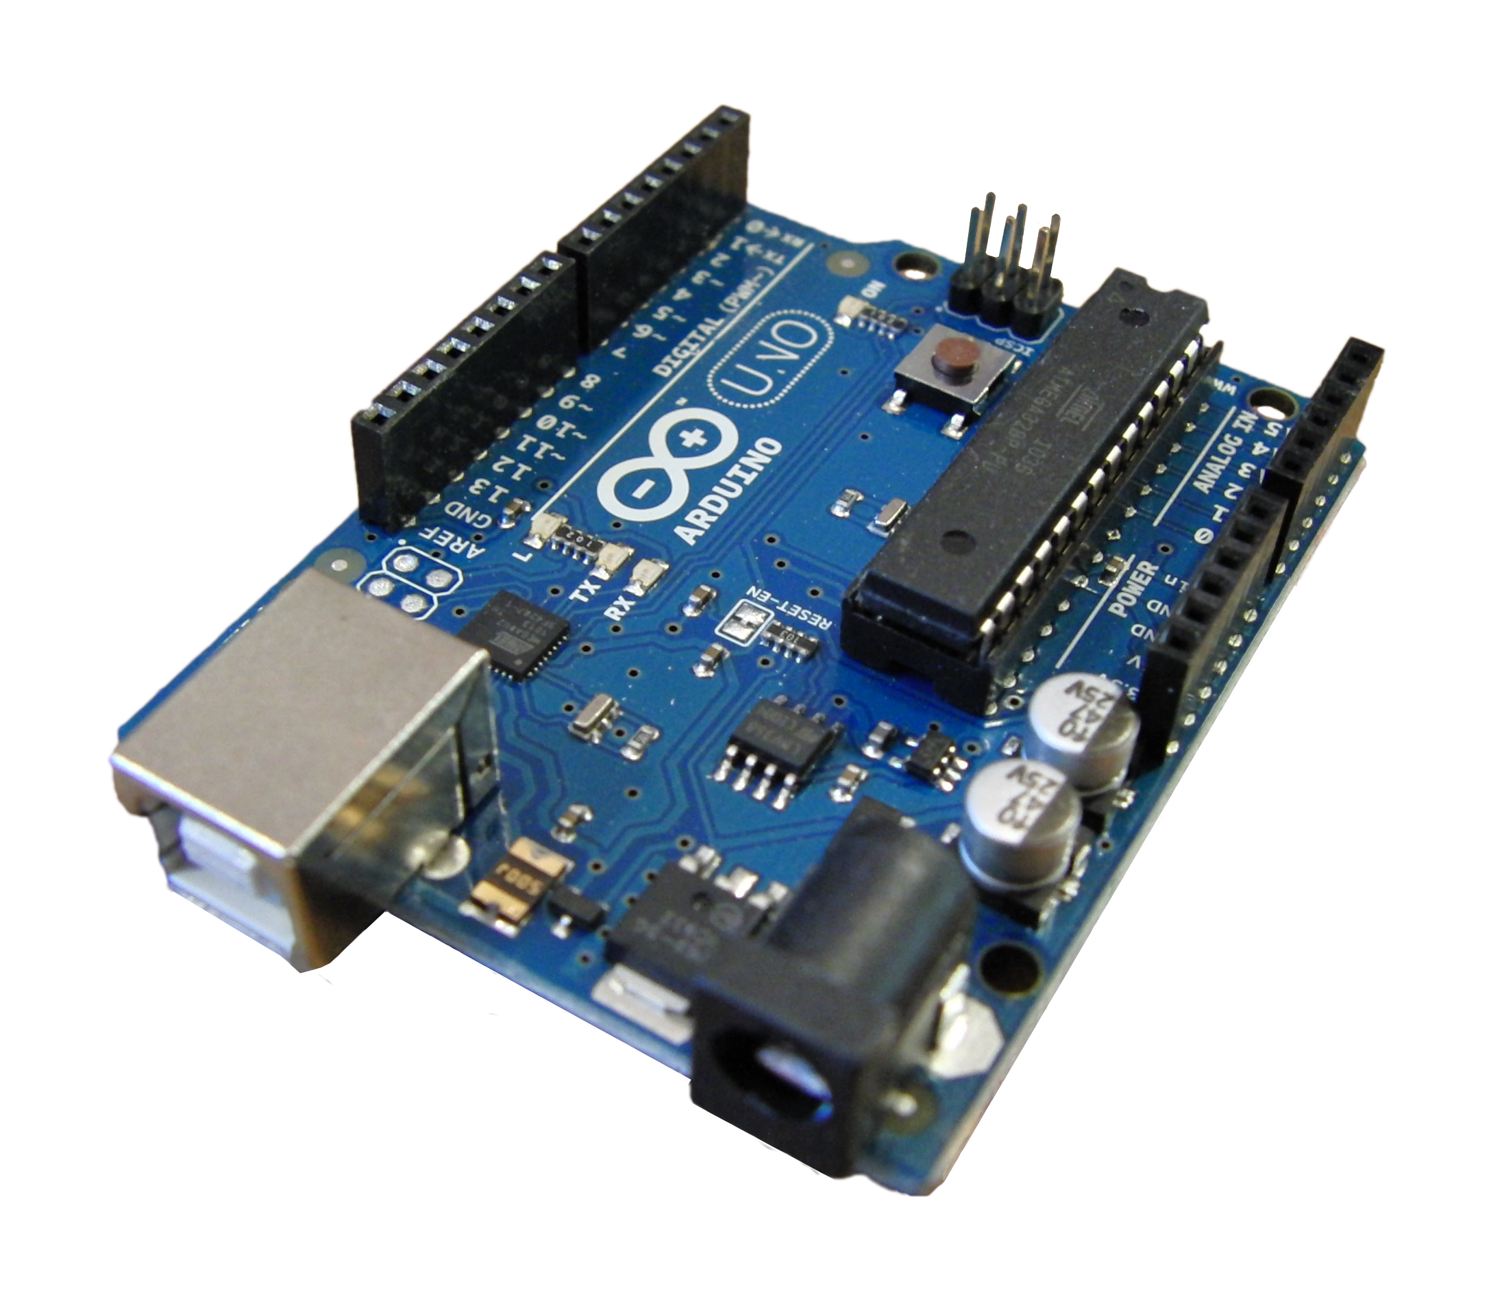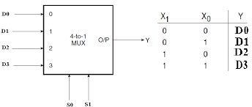

We use 2 inputs only S1 & S2 where we can change their values as in the truth table shown above obtaining 1 specific output –out of four- without using 4 pins.

Logically we can represent our model as the following logic circuit using NOT and AND gates, where A & B are the two only used pins and their values decide whether the output will be D0, D1, D2 or D3.

